Changes to the intensity of precipitation due to climate change
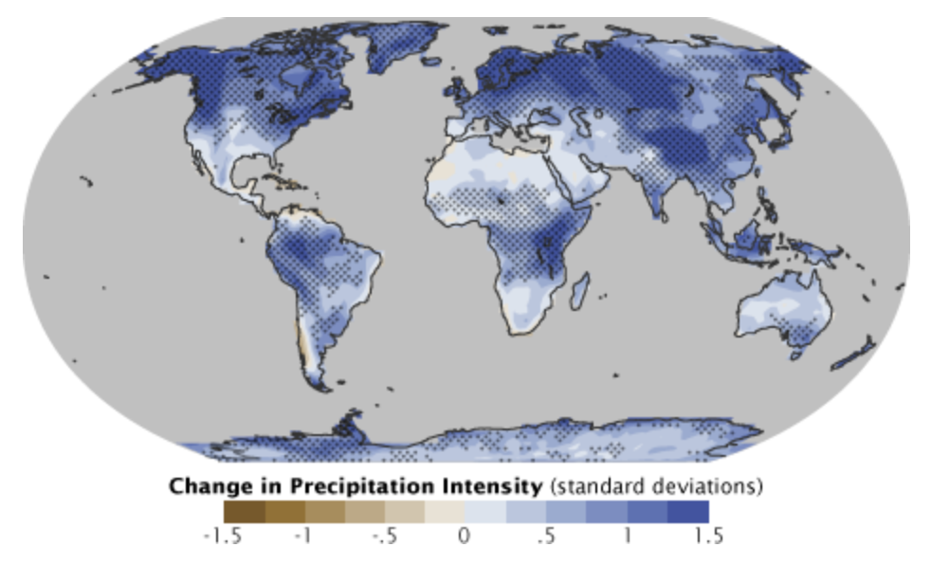

One expected effect of climate change will be an increase in precipitation intensity: a larger proportion of rain will fall in a shorter amount of time than it has historically. Blue represents areas where climate models predict an increase in intensity by the end of the 21st century, brown represents a predicted decrease. (Map adapted from the IPCC Fourth Assessment Report.)

Links for study of changes to the water cycle:

Humans are taking too much water out of the groundwater basins
https://www.livescience.com/51483-groundwater-basins-running-out-of-water.html

How deforestation of the Amazon rainforest affects the water cycle
https://www.nationalgeographic.com/environment/2018/11/how-cutting-the-amazon-forest-could-affect-weather/

How eating meat affects your water footprint
https://www.onegreenplanet.org/animalsandnature/how-does-eating-meat-impact-your-water-footprint/

