Resume Formatting
Look through different student resume templates. Select 2 resumes you like, one from the modern style (top examples below), and one from the traditional style (bottom examples below).
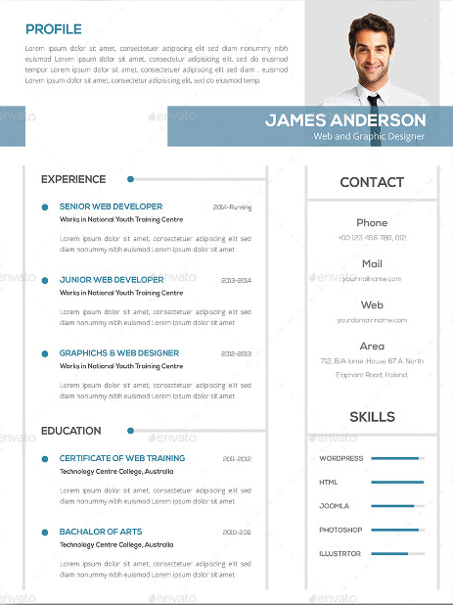
Modern Styles
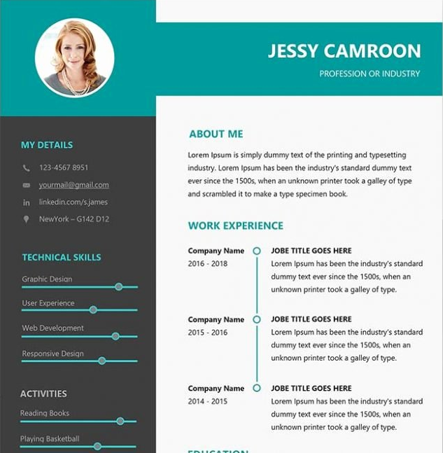

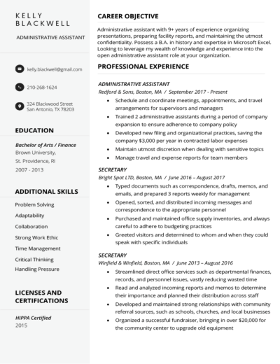
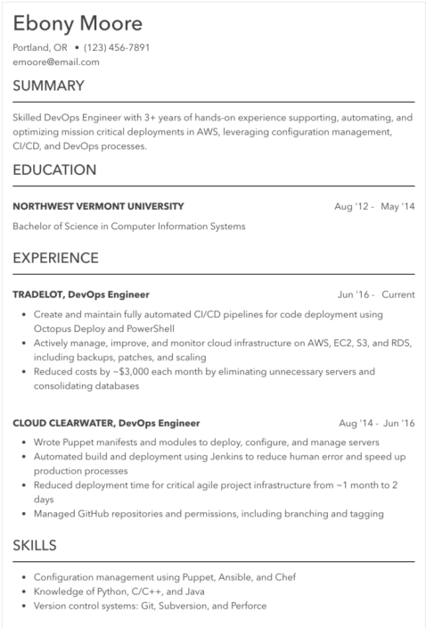
Traditional Styles

You will create a student resume for yourself in each of the styles. You may “copy” a template you like, or design your own based on your research. If you use color, don’t go overboard – resumes are professional documents, not artwork.

The focus of this project is formatting your document, but it is also CRITICAL that your resume does not have ANY flaws. Proofread, use the spell/grammar check, and make sure you get your information correct. Your finished resumes should be saved to your digital portfolio in SeeSaw. It is a good idea to save the original as a word document, then to save it again as a PDF.

