Name _________________________________________________________ Date _________________________
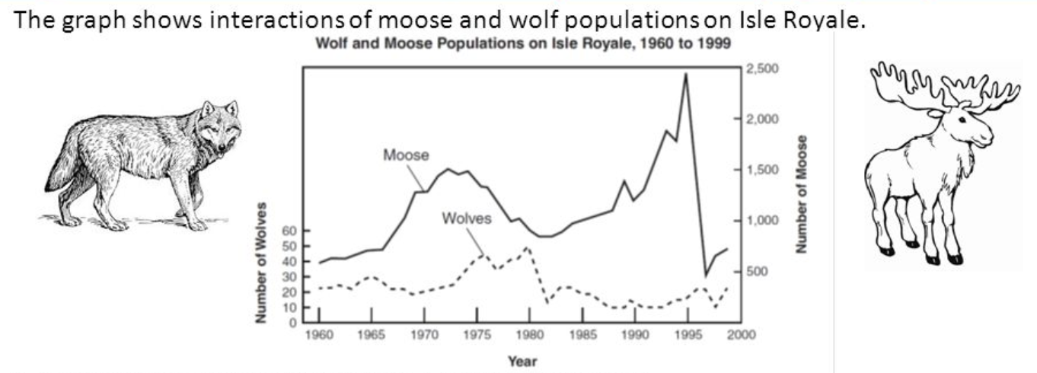

1. State one possible reason for the change in the moose population between 1995 and 1997.

2. If the wolf population had been higher in 1992, how would you expect the moose population to have been affected? Explain.

3. If the population of grass were plotted on the above graph, do you think it would have been higher or lower than the line for the moose between 1992-1995? Explain.

4. If the population of grass were plotted on the graph, how do you think it would have changed between 1995 and 1997? Explain.

5. Do you think the decline in the number of wolves between 1980 and 1982 was caused by a lack of food? Explain.

The following data represent changes to the population of squirrels in a forest ecosystem.

Year | Number of Births | Number of Deaths | Number that Immigrated | Number that Emigrated
2018 | 12 | 3 | 8 | 3
2010 | 14 | 4 | 2 | 16

6. Calculate the change in the population of squirrels in 2018.

7. Calculate the change in the population of squirrels in 2010.

8. Did the number of squirrels decrease during either of the years? If so, which one(s)?

9. Was limited resources or predation the more likely reason for the change in the squirrel population during 2010? Explain.

10. If all of the change in the squirrel population was due to predation, would the data suggest an increase, decrease, or no change to the number of squirrel predators in the ecosystem between 2010 and 2018?

