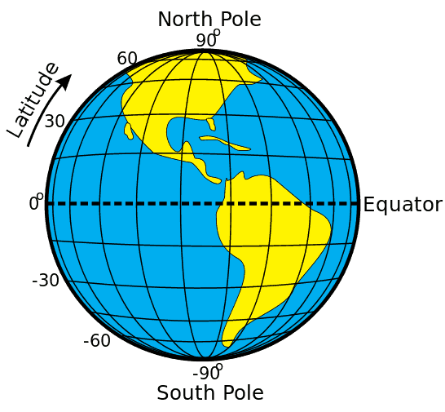



High pressure band

Low pressure band

High pressure band

Low pressure band

Low pressure band