Answers to the Guided Questions for March 16-17
Use the PowerPoint slides 2-10 to answer these questions.

1. Is surface water in the ocean usually warmer or colder than deep water in the ocean? Why?
Surface water is usually warmer, because warm water is less dense, and cold water is denser. Therefore, cold water sinks, making the surface warmer.

2. How does the temperature of water traveling from the north pole towards the equator compare to the temperature of water traveling from the equator towards the north pole?
Water traveling from the north pole towards the equator starts out cold, but as it approaches the equator it gets warmer due to the uneven heating of the Earth, which provides more sunlight at the equator than at other latitudes. In contrast, water leaving the equator traveling towards the poles starts out warm, but gets cooler as it approaches the poles.
This changing of the water temperature as it moves to or from the equator creates ocean convection currents that move deep ocean water up as it warms and warm ocean water down as it cools.

3. What is the role of the Global Ocean Conveyor Belt?
The Global Ocean Conveyor Belt moves heat and nutrients through the ocean waters.

4. What moves surface water in the ocean?
Surface water is moved by winds.

5. What moves deep water in the ocean?
Deep ocean water is moved by differences in the densities of ocean water. These differences can be caused by different temperatures, or differences in salinity (amount of salt).

6. When ice forms in the ocean, how does the amount of salt in the water change? Why is this important? (What happens because of the change in salt concentration?)
Ice forms by water freezing. Like in evaporation, only the water freezes, no salt is present in sea ice. This means that the salinity (the amount of salt) in the remaining water is greater than before the ice formed. This will cause the surface, where the ice formed, to become denser, and the surface water will sink.

7. Write a description of this model of ocean water movement. Specifically discuss each of the 4 labels on the model (Sea-to-Air Heat Transfer, etc.), and how the currents work.
Sea-to-Air Heat Transfer occurs as the warm surface waters from the equator move towards the colder poles. Heat flows from hot to cold, so the warmer water transfers some of its heat to the air. As the surface water transfers heat to the air, it becomes colder, which causes it to sink. This is part of the great ocean water movement that distributes heat and nutrients. Sea-to-Air Heat Transfer also helps to make the temperatures in the area less extreme. Although the poles are cold, without the Sea-to-Air Heat Transfer, the poles would be even colder.
Solar Warming of Ocean Waters occurs as cold surface water moves towards the warmer latitudes, particularly near the equator. The direct sunlight in the tropical zone transfers heat to the water better than the less direct sunlight in the polar zone. Near the equator, sunlight transfers enough heat to the water that it warms a little below the surface, causing the water to rise as it becomes less dense.
Warm shallow currents are the surface waters. These waters are warmer than the deep ocean, but can be up to 300 feet deep. Sunlight is able to penetrate these waters to transfer heat, making the water less dense. The surface is not as salty, either, since saltier water sinks.
Cold and salty deep currents are about 1000 or more feet below the ocean surface. The sunlight cannot reach this far, so this water is much colder. Since cold water is denser, this water stays below the warmer surface waters. This water contains more salt, too, since saltier water sinks.

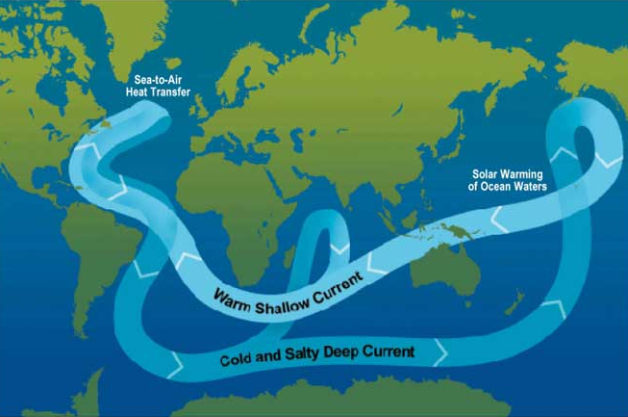

8. If upwelling did not occur, would the ocean be able to support as many organisms? (If you need help with this question, look at the following resource) https://oceanexplorer.noaa.gov/edu/learning/8_ocean_currents/activities/currents.html
Upwelling brings deep, nutrient rich water from deep in the ocean to the surface. It is critical for supporting the marine life in the ocean. The nutrients would not be sufficient without upwelling to support the large populations of organisms. Areas where upwelling occurs have very large fish populations after upwelling, but over time, the Global Ocean Conveyor Belt moves some of the extra nutrients to farther locations.

Answers to the Guided Questions for March 18-20
Use the PowerPoint slides 11-21 to answer these questions.

9. The air in a convection current is always colder in the atmosphere and warmer on Earth’s surface. (Fill in with warmer or colder)

10. Air always moves from high pressure to low pressure. (Fill in with low or high)

11. What causes air to form convection currents and winds?
Differences in temperature caused by the uneven heating of the Earth causes differences in density of air. Warm air is less dense, so it rises, and cold air is denser, so it sinks. Since cold air is denser, the pressure of cold air is higher than the pressure of warm air. This causes wind to move air from the high pressure area to the low pressure area, making the pressures more balanced.

12. What are the most important features of climate?
Climate is primarily determined by temperature and precipitation.

13. How does latitude affect temperature? (Why do different latitudes have different characteristic temperatures?)
Different latitudes receive different amounts of thermal energy from the sun. Since latitudes near the equator get the most direct sunlight, they are warmer than latitudes nearer the poles, which receive the least direct sunlight, and are therefore the coldest.

14. Why do mountains often have a desert on one side? (Give a thorough explanation including how elevation affects precipitation.)
Mountains require air to rise over the top of them. In the process, the air loses heat, since the temperature at higher altitudes is lower than the temperature near Earth’s surface. As the air cools going over the mountain, water in the air condenses into clouds, and then falls as precipitation onto the mountain. This happens on the side of the mountain where the air had to rise over the mountain. By the time the air gets to the other side of the mountain, the air has lost most of the water, and the air begins to warm as it sinks closer to Earth’s surface going down the mountain. This means that there is little water on the side of the mountain where the air is going down – it is often a desert.

15. Which gets colder in the winter, the land, or the ocean? Why?
Land gains and loses heat faster than water does, so during the winter, the land gets colder than the ocean.

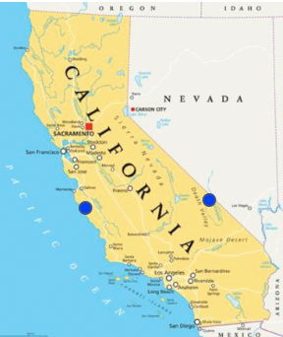
16. Would the coastal side of California marked by the blue spot be hotter or colder than the Nevada side of California marked by the blue spot, hundreds of miles inland? Why?
The coastal side of California will be warmer in the winter than the inland side of California (the Nevada side), but it will be colder in the summer than the inland side. This means that the coast will be more even in temperature, and inland will have greater differences between the high and low temperatures in different seasons. Coastal areas are known for this mild climate, not too hot or too cold. This is because the water does not change temperature as much as the land does, and the ocean is a lot of water! The relatively stable water temperature helps to keep the nearby land at a temperature closer to the water temperature than the land at the same latitude, but inland (far from the ocean).

