Guided Questions for March 16-17
Use the PowerPoint slides 2-10 to answer these questions.

1. Is surface water in the ocean usually warmer or colder than deep water in the ocean? Why?

2. How does the temperature of water traveling from the north pole towards the equator compare to the temperature of water traveling from the equator towards the north pole?

3. What is the role of the Global Ocean Conveyor Belt?

4. What moves surface water in the ocean?

5. What moves deep water in the ocean?

6. When ice forms in the ocean, how does the amount of salt in the water change? Why is this important? (What happens because of the change in salt concentration?)

7. Write a description of this model of ocean water movement. Specifically discuss each of the 4 labels on the model (Sea-to-Air Heat Transfer, etc.), and how the currents work.
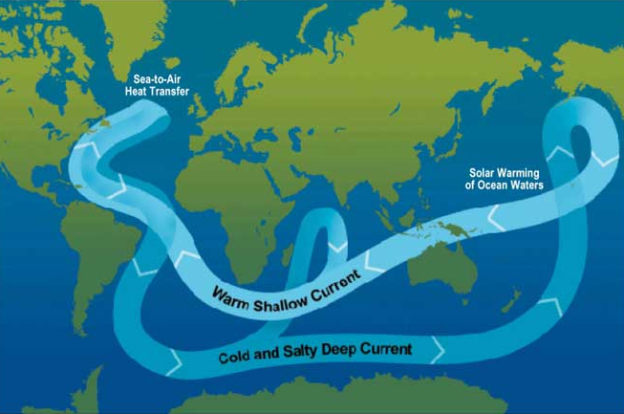

8. If upwelling did not occur, would the ocean be able to support as many organisms? (If you need help with this question, look at the following resource) https://oceanexplorer.noaa.gov/edu/learning/8_ocean_currents/activities/currents.html

Guided Questions for March 18-20
Use the PowerPoint slides 11-21 to answer these questions.

9. The air in a convection current is always ______________ in the atmosphere and ______________ on Earth’s surface. (Fill in with warmer or colder)

10. Air always moves from ______________ pressure to ______________ pressure. (Fill in with low or high)

11. What causes air to form convection currents and winds?

12. What are the most important features of climate?

13. How does latitude affect temperature? (Why do different latitudes have different characteristic temperatures?)

14. Why do mountains often have a desert on one side? (Give a thorough explanation including how elevation affects precipitation.)

15. Which gets colder in the winter, the land, or the ocean? Why?
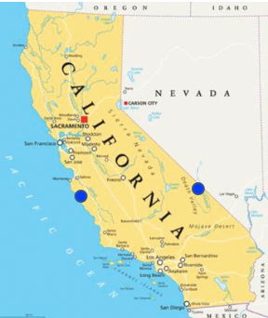
16. Would the coastal side of California marked by the blue spot be hotter or colder than the Nevada side of California marked by the blue spot, hundreds of miles inland? Why?

